Group name | INDIA CLIENT - LVCLA04-2026-IDA | Code | 250606150149
Version | 1 | Sales consultant | Sales Team
zGroup size | 2 - 32 pax(s) | Validity | 01 Jan 2026 - 31 Dec 2026

LVCLA04-2026-IDA-5D4N-HANOI-HALONG-SAIGON
Highlights
- Explore Halong Bay – The area is recognized as the World Natural Heritage. The bay features thousands of limestone karsts and isles in various shapes and sizes.
- Mekong 1 Day Tour (My Tho – Ben Tre) takes you on a wonderful journey to explore the poetic and culturally diverse Mekong Delta.
- Special gift: each pax will be given Vietnamese Instant Coffee

Introduction:
Halong - as one of the New Seven Wonders of the Natural World, Halong Bay Vietnam is a place where your imagination can run wild in between the local fanciful legends and viewing the mysterious landscape. From uninhabited white beaches, fresh sea-food, unparalleled wildlife, deep caves, world class cruises, and unique karst formations, this is a destination that has it all for any type of traveler.
Saigon is a very populated city that seems to never sleep. The lifestyle here is constantly filled with
interesting and novel things because this is a gathering place for many people from various cultural
backgrounds across the nation. It is a tasteful blending of contemporary and traditional elements.
Many small alleys with historically significant values can be found right behind taller buildings or in
the middle of the city.

Day 1: Hanoi arrival + Afternoon city tour
Welcome to Vietnam - a land of untouched nature, primeval forests and dusty roads!
Upon arrival in the airport, meet up our guide and transfer to hotel. (Check – in after 14 pm).
Afternoon, visit to picturesque West Lake and the sixth century Tran Quoc Buddhist Pagoda
Continue to visit Hoan Kiem Lake (Sword Lake) and its surrounding includes: Dong Kinh Nghia Thuc Square, Hanoi Opera House, St. Joseph’s Cathedral (outside) and Ngoc Son Temple with Sunrise Bridge then we will go through around Hanoi’s Old Quarter for shopping.
Overnight in Hanoi.
Distance Noi Bai Airport – Hanoi Central: 35km -> 45 minute transfer

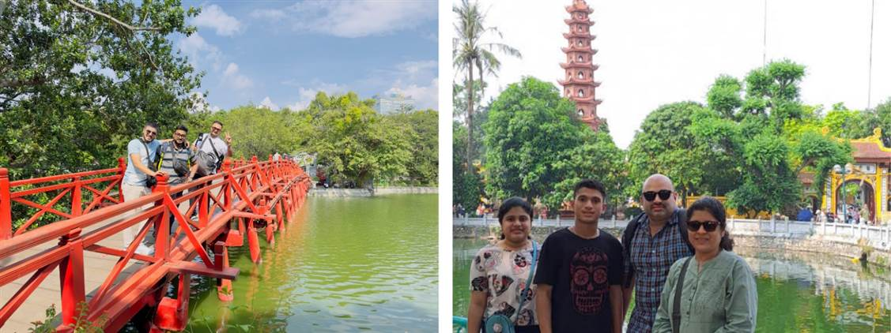
Hoan Kiem Lake Tran Quoc Buddhist Pagoda

Day 2: Hanoi - Halong Overnight Cruise (B/L/D)
This morning travel by road through the Red River Delta to beautiful Halong Bay. The scenic drive will pass through rural landscapes before arriving at this World Heritage site. Upon arrival board the Boat where you will enjoy a welcome drink and a delicious freshly caught seafood lunch whilst sailing out of the bay passing amazing shaped mountains.

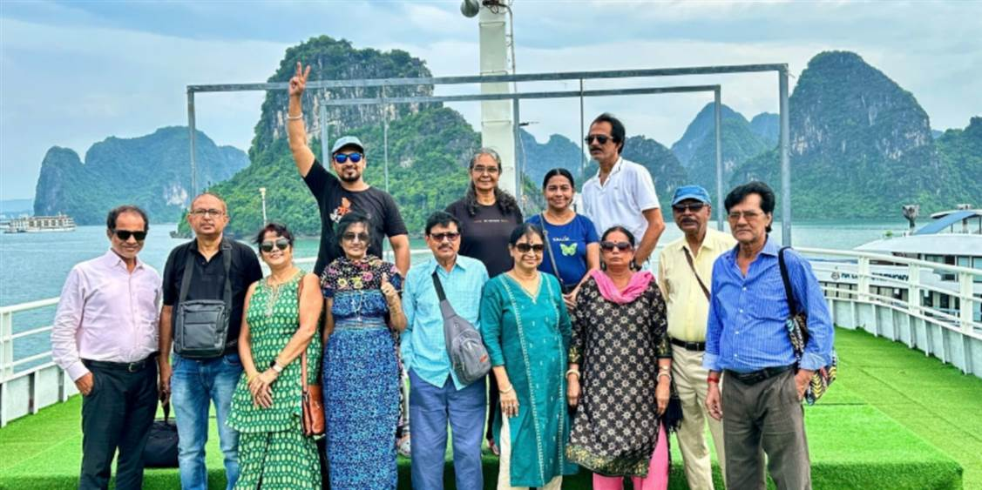
Overnight on Cruise
Meals Breakfast at Hotel
Lunch and dinner on Cruise (Vietnamese Cuisine)
Distance Hanoi – Halong: 165km -> 4 hour transfer included breaktime on the way
Note: Itinerary in Halong Bay is subject to change without prior notice

The overview of Ha Long Bay

Day 3: Halong Cruise - Hanoi - Saigon (B)
Enjoy early morning view of the bay’s landscape. Enjoy the breath-taking beauty of the rocky islands rising from the water of the bay. Sailing back to the Harbour. After check out drive back to Hanoi and to the airport for your filight to Saigon. Upon arriving in Saigon, our guide will take you to the hotel.
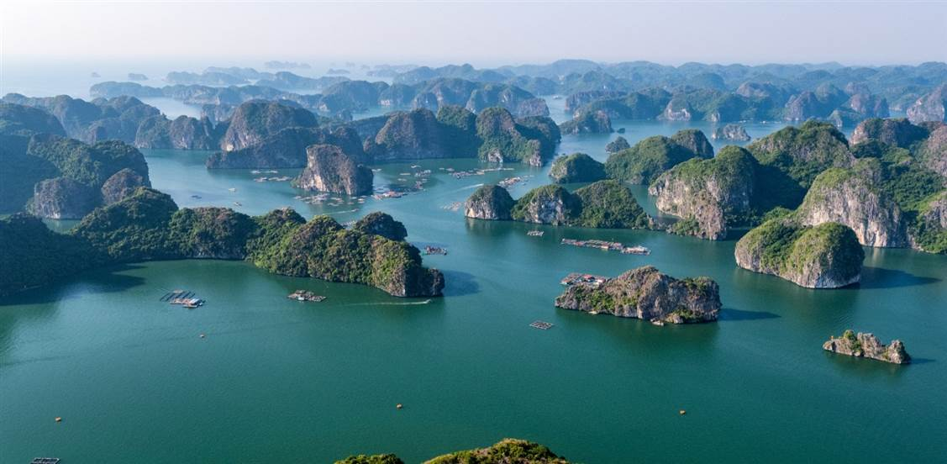
The overview of Ha Long Bay
Overnight in Saigon.
Meals Breakfast or Brunch on cruise (Depended on each cruise)
Distance Halong - Hanoi: 165km -> 4 hour transfer included breaktime on the way
Note: Itinerary in Halong Bay is subject to change without prior notice
*Filght: VN 259 HAN - SGN 18:00 20:15 ( Ticket price excluded )

Day 4: Saigon - Mekong Delta - Saigon (B)
Transfer to outskirt of Saigon and begins the tour on the beautiful countryside road.
Start at Tourist Boat Station (My Tho), cruising on Tien (Mekong) river and seeing four islands: Dragon, Unicorn, Tortoise, Phoenix. Enjoy fresh coconut juice. Stop at Thoi Son Island, go walking around countryside road, seeing orchards, enjoy tropical fruits and listen to traditional music. Take a rowing boat on small canal with beautiful scenery of country side, to visit honey-bee farm and enjoy honey-tea. Drive back to Saigon.

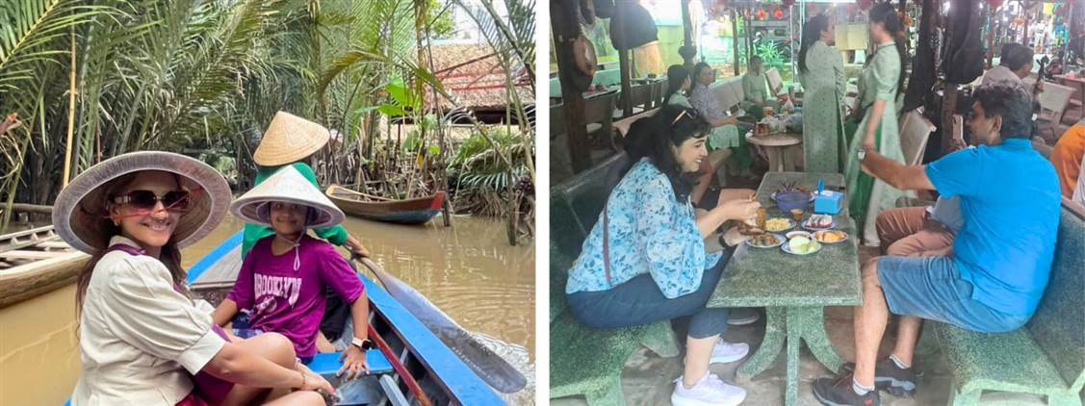
Cruising on Tien – My Tho (Mekong) Enjoy honey-tea
Overnight in Saigon
Meals Breakfast at hotel
Distance Saigon Central - My Tho: 75km -> 2 hour transfer

Cruising on Tien – My Tho (Mekong)

Day 5: Departure (B)
Free time to relax till our guide takes you to airport for your onward flight (check-out before 12 at noon).
Meals Breakfast at hotel

End of services

List of accommodations
Location | 4 star | 5 star
Ha Noi | Sunway, Lacasa hotel, The Q, MK Premier * * * * (ROH) | Pan Pacific, Apricot, Du Parc * * * * * (ROH)
Halong Overnight Cruise | Indochina Sail, Amanda Premier, Calypso (Deluxe ocean view) | Indochine cruise; Paradise Elegance, Paradise Grand, Ambassador (Junior Suite)
Saigon | Kin, Paragon, Northen Charm, Muong Thanh Grand * * * * (ROH) | Grand Saigon, Equatorial * * * * * (Deluxe)

Rates and Conditions
Prices are in USD per person, based on two guests sharing a twin or double room in the hotels mentioned above.
Below rates are not valid for the period of Christmas (24 Dec 2026) and New Year (31 Dec 2026 – 1 Jan 2027), Vietnamese New Year (16 Feb 2026 – 22 Feb 2026), Independence Day (30 Apr 2026), May Day (1 May 2026), National Day (02 Sep 2026), etc. Please contact us for further details in terms of specific dates.

- Main Tour cost

High season
1st Jan – 30th April & 1st Oct – 31st Dec 2026
Group size | 2 | 3 | 4 | 5 | 6 | 7-9 | 10-15 | 16-18  1 FOC | 19-21  1 FOC | 22-24  1 FOC |  | 25-28  1 FOC |  | 29-31  1 FOC |  | 32  2 FOC |  | SGL supplement
4* | 563 | 460 | 418 | 382 | 360 | 344 | 332 | 322 | 309 | 303 |  | 298 |  | 296 |  | 294 |  | 180
5* | 670 | 568 | 527 | 491 | 470 | 454 | 448 | 445 | 431 | 424 |  | 422 |  | 419 |  | 417 |  | 254
Low season
1st May – 30th Sep 2026
Group size | 2 | 3 | 4 | 5 | 6 | 7-9 | 10-15 | 16-18  1 FOC | 19-21  1 FOC | 22-24  1 FOC | 25-28  1 FOC |  | 29-31  1 FOC |  | 32  2 FOC |  | SGL supplement
4* | 549 | 449 | 409 | 374 | 352 | 336 | 325 | 315 | 303 | 296 | 292 |  | 288 |  | 286 |  | 177
5* | 650 | 553 | 512 | 478 | 456 | 442 | 435 | 432 | 419 | 412 | 410 |  | 408 |  | 405 |  | 244
2. Optional cost for Hotel Early Check-In/Late Check-Out
- Standard check-in time at hotel: after 14h00
- Standard check-out time at hotel: before 12h00 at noon
Price for Early check-in/Late check-out per double/twin room in USD:

Location | Period | 4 star | 5 star
Hanoi | Year round | 72 | 159
Saigon | High season | 84 | 114
 | Low season | 80 | 105

3. Optional cost for meals in restaurants
- Vietnamese Lunch/Dinner: Suggested from 11 USD/person/meal.
- Indian Lunch/Dinner( In Hanoi, Saigon): Suggested from 13 USD/person/meal.
If you want to book meals through us, extra charge for guide & transfer to escort will be added as below:
Price per person in USD
Group size/Price per person | 2 | 3 | 4 | 5 | 6 | 7-9 | 10-15 | 16-18 | 19-21 | 22-24 | 25-28 | 29-31 | 32
Transfer & guide escort charge for a meal in Hanoi | 17 | 12 | 10 | 8 | 6 | 6 | 5 | 4 | 4 | 4 | 4 | 3 | 3
Transfer & guide escort charge for a meal in Saigon | 19 | 14 | 11 | 9 | 7 | 6 | 6 | 5 | 4 | 4 | 4 | 4 | 4
Note: There won’t be any escort charge to Lunch on a full day tour (Applied for restaurants in the central location only).
Inclusions  • Accommodation in the category chosen or similar (subject to availability)  • Meals as mentioned in the program. B= Breakfast, L=Lunch, D=Dinner  • Shared 1 night cruise on Halong Bay. (Private cabin)  • Transfer from and to the airports by private vehicle with A/C. Transportation by private vehicle with A/C.  • All entrance fees and sightseeing as mentioned in the program.  • Local English speaking guide(s) as mentioned.  • In house sharing English speaking guide on cruise in Halong Bay. If you need our private guide, please let us know, we will advise you surcharge if any.  • Mineral water with 2 bottles of 500ml/ tour day/ pax  • Free 1 box of G7 coffee 288gram as gift for each pax | Exclusions  • Early check-in/late check-out (if not mentioned). Surcharges for transfer from 21:00 - 06:00.  • Compulsory TIPPING for local guide and van driver  + 1-2 pax: 10 USD/ pax/ day  +3-4 pax: 7USD/ pax/ day  +5-7pax: 5USD/ pax/ day  +8-9pax: 4 USD/ pax/ tour  +10 pax up: 3 USD/ pax/ tour  • Suggested TIPPING for bellboy, boat crew, sampan driver: based on your satisfies  • Surcharges for Holidays  • Meals and drinks which are not mentioned in the program  • International flight tickets and airport taxes. All internal/ regional flight tickets in economy class  • Visa fees upon arrival in Vietnam.  • Tips & personal expenses. Personal insurance. Any services not clearly mentioned in the program.

GENERAL TERMS & CONDITIONS
Remarks for check in and check out schedules
Check in time: at hotel: after 14h00 – on cruise: before 12h00.
Check out time: at hotel & on cruise: before 12h00
Remarks for itinerary
The itinerary and schedule are subject to change due to local traffic situations, weather conditions; flight, or any un-foreseen circumstances or local authority decision. LV Travel reserves full rights to replace all items with same values for guests.
Remarks for meal
Meals are fusion on local food with daily normal buffet breakfast at hotel. Guests should advise any special food preferences, allergies or dietary requirements at least one (1) week prior to the arrival date.
Remarks for the price
16 full paying pax group is granted one FOC based on half twin (exclusive of extra service).
Please be aware that any changes in the itinerary due to unforeseen circumstances might result in increase in pricing.
Any damage caused to all services during the stay shall be payable by the passengers.
Validity
All prices quoted to the Client/Agent are on a net basis in United States Dollars and valid according to the date specified on the LV Travel printed tariffs and/or quotation and/or invoice issued to the Client/Agent. LV Travel warrants that the prices or rates quoted to the Client/Agent are correct at the time of issuance or invoice but are subject to change in line with market, tax or currency fluctuation, with or without prior notice.
Payment method
Unless otherwise agreed by LV Travel, client’s payment shall be executed by bank transfer, to the LV travel’s bank account clearly noted in all the invoices. Every party shall take care of the transfer fees occurring with its relevant bank.
Payment conditions for domestic or international flights : We will check case by case.
Payment conditions for land tour without flights:
-Upon the confirmation of the document: a deposit of 30% total price is required 03 months prior to the group’s arrival in Indochina, in order to secure all services
- The full payment of entire 70% of the total price must be transferred to the LV travel’s bank account 30 days prior to the group arrival in Indochina, if not agreed otherwise.
Cancellation of domestic or international flights: We will check case by case.
Cancellation policy:
- All cancellations should be made in writing and should be acknowledged by LV travel.
-Cancellation Rules for Land Tour, not apply for domestic or international flights (if any).
- Cancellation more than 45 days prior to the group arrival: No Charge. Deposit shall be deducted into the next bookings, except specified suppliers require cancellation fees.
- Cancellation between the 45th and 31st day prior to the group arrival: 25% of the total tour price.
- Cancellation between the 30th and 23rd day prior to the group arrival: 30% of the total tour price.
- Cancellation between the 22nd and 16th day prior to the group arrival: 40% of the total tour price.
- Cancellation between the 15nd and 09th day prior to the group arrival: 60% of the total tour price.
- Cancellation between the 08nd and 03rd day prior to the group arrival: 80% of the total tour price.
- Cancellation between the 02nd and 0th day prior to the group arrival: 100% of the total tour price.
- In case the tour participant(s) shorten or interrupt the tour of their own accord there will be no reimbursements.
- Reduction in the number of passengers against requested bookings is considered and treated as cancellations.
- If the balance of the tour invoice is not received by the deadline of 14 days prior to the group arrival, LV Travel will reserve the right to cancel the reservation without indemnity or any reimbursement.
- If LV Travel is forced to cancel the departure due to unforeseeable reasons, the participants will be fully reimbursed without intention to claim for any indemnities.

Contact details
Hotline for sales (ms Moon) | +84 888 905 286 (WA/viber/mobile)
Hotline for operation (ms Anna Hanh) | +84 983 096 032(WA/viber/mobile)
General Manager Mr Len | +84 989 200 116 (WA/viber/mobile)

